DATABASE SYSTEM ENGINEERING AND DISTRIBUTED BACKEND DEVELOPMENT
Course Code: 25CS13002E
ROLL NO: 2520030245
NAME: MEGHANA SAI

TABLE CREATION AND DATA INSERTION
Create Table:
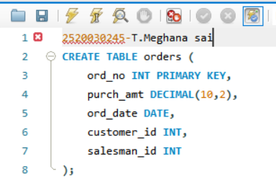
Output:
Insert Sample Data:
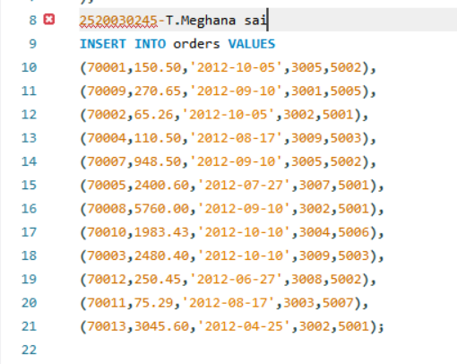
Output:
SECTION 1 : WHERE AND ORDER BY
Query 1: WHERE CLAUSE
Query / Code:
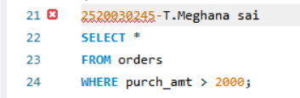
Output:
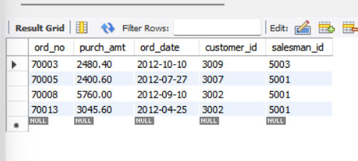

Query 2: WHERE CLAUSE
Query / Code:
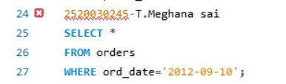
Output:
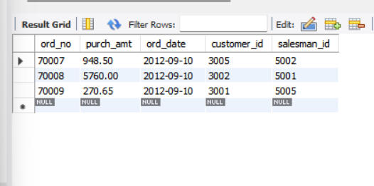

Query 3: WHERE CLAUSE
Query / Code:
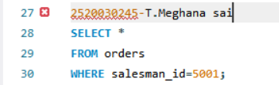
Output:
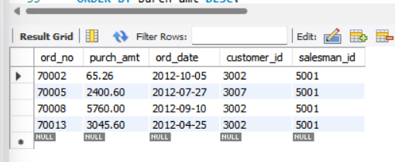

Query 4: ORDER BY
Query / Code:
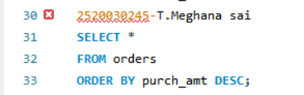
Output:
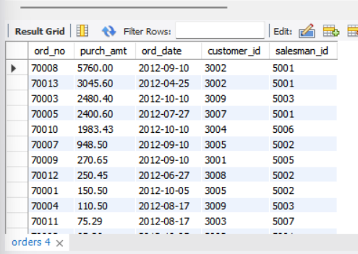

Query 5: ORDER BY
Query / Code:

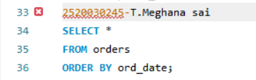
Output:
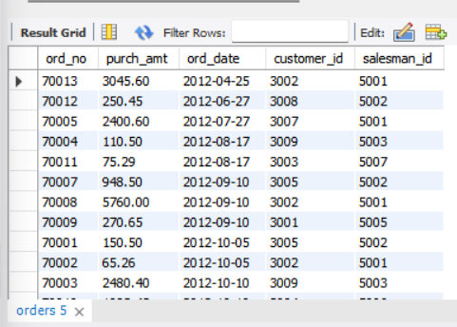

SECTION 2 : AGGREGATE FUNCTIONS
Query 6: SUM()
Query / Code:
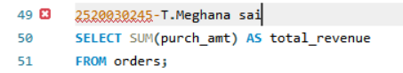
Output:
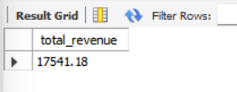

Query 7: AVG()
Query / Code:
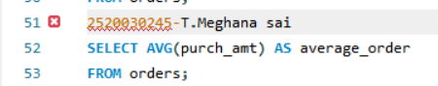
Output:
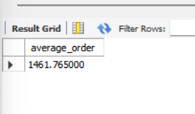

Query 8: MAX()
Query / Code:
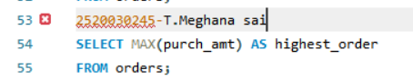
Output:
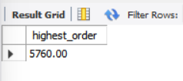

Query 9: MIN()
Query / Code:
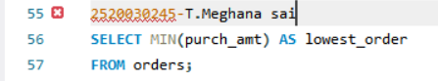
Output:
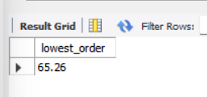

Query 10: COUNT()
Query / Code:
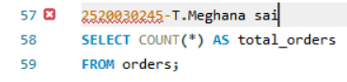
Output:
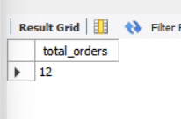

SECTION 3 : GROUP BY
Query 11: GROUP BY
Query / Code:
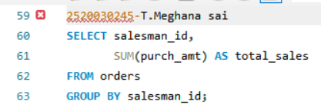
Output:
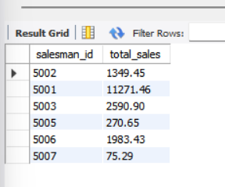

Query 12: GROUP BY
Query / Code:
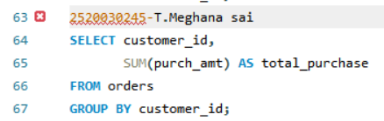
Output:

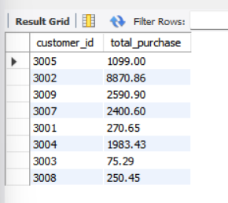

Query 13: GROUP BY + MAX()
Query / Code:
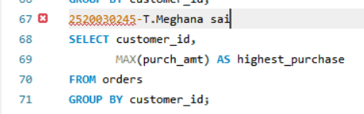
Output:
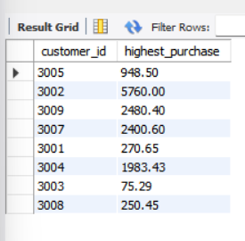

SECTION 4 : GROUP BY + HAVING
Query 14: GROUP BY + HAVING
Query / Code:
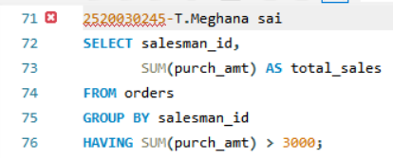
Output:
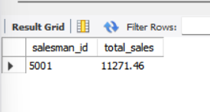

Query 15: GROUP BY + HAVING
Query / Code:
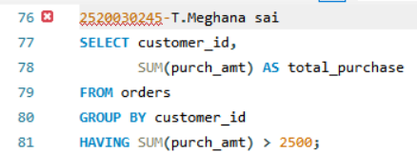
Output:
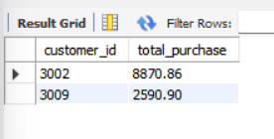

Query 16: GROUP BY + HAVING
Query / Code:
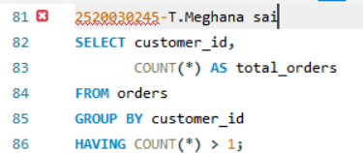
Output:
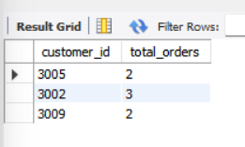

SECTION 5 : ADVANCED GROUP BY / HAVING
Query 17: GROUP BY + HAVING + ORDER BY
Query / Code:
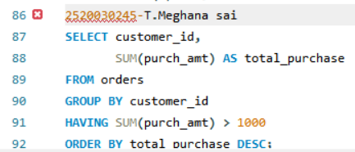
Output:
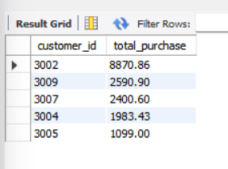

Query 18: BETWEEN + HAVING
Query / Code:
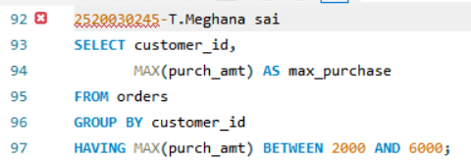
Output:
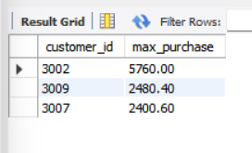

Query 19: COUNT + HAVING
Query / Code:
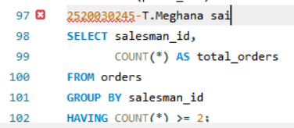
Output:
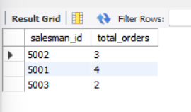

Query 20: MAX + GROUP BY + HAVING
Query / Code:
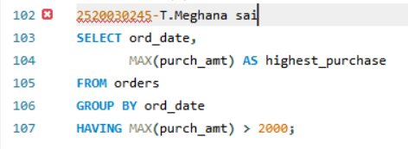
Output:
